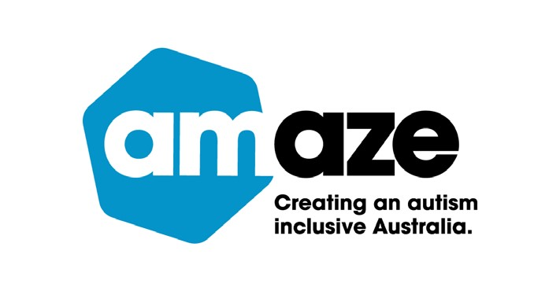

Hoodie Up 2025

Communications kit

April 2025

# Hoodie Up communications kit

## Hoodie Up campaign background

Hoodie Up is Amaze’s annual fundraiser and Autism awareness campaign.

The 2025 theme is ‘My Positive Autistic Identity’. Its purpose is

1. To engage corporate and community audiences to show support for Autistic staff

2. To engage the Autistic community to show Autistic pride by wearing hoodies and sharing on socials with the hashtags **#HoodieUp2025 #MyPositiveAutisticIdentity**

The campaign is focused for the month of April with awareness and engagement activities and continued throughout the year.

## Questions?

If you have any questions or would like advice on how to run your Hoodie Up campaign or event, please contact Amaze by email below:

Businesses and organisations can contact **inclusion@amaze.org.au**

Schools and community organisations can contact **community@amaze.org.au**

Anyone in the community can contact **info@amaze.org.au**

## Purpose of this kit

Amaze is sharing this kit with you to make it easy for you to spread the word about the Hoodie Up campaign. This promotion pack includes copy and images for you to use on your website, newsletters and on social media.

Please direct your audience to the Amaze Hoodie Up official webpage [**Hoodie Up for Autism - Amaze**](https://www.amaze.org.au/get-involved/hoodie-up/)

Thanks for your support.

## Copy and images to use for schools

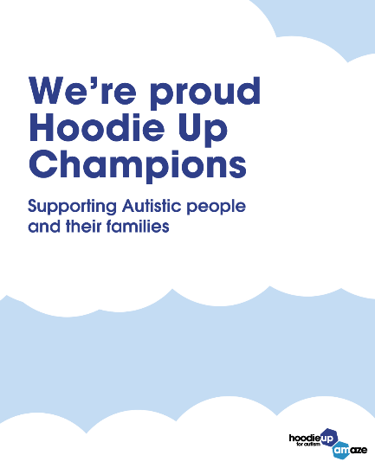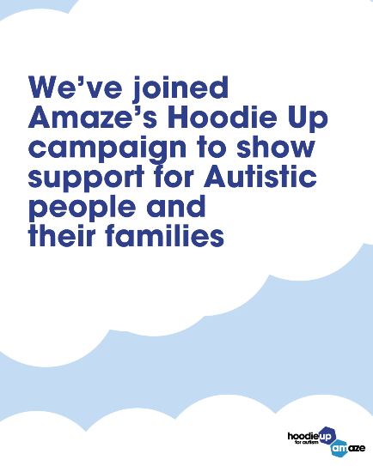 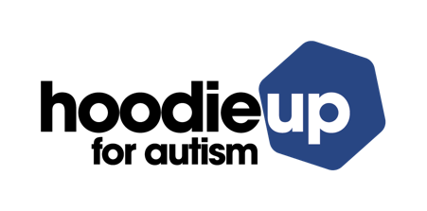

### Newsletter

**Championing Autistic Inclusion: Celebrating Hoodie Up 2025!**

Our school proudly joined Amaze’s Hoodie Up campaign, an annual campaign that shines a light on strengths, uniqueness, and the pride of being Autistic.

Hoodie Up is an opportunity for our school community to learn more about how we can celebrate and uplift the Autistic community, ensuring that we create an environment where all students have the opportunity to thrive.

We encourage all members of our school community to reflect on how we can continue to foster and promote inclusion in society, by continuing to listen, learn and lead with kindness and understanding.

Together, we can make our school a place where Autistic students and their families are celebrated for the rich diversity, unique perspectives, and incredible contributions that they bring to our school and wider community.

You can contact Amaze if you have any questions at [**community@amaze.org.au**](mailto:community@amaze.org.au)or read more on Amaze’s website [**Hoodie Up for Autism - Amaze**](https://www.amaze.org.au/get-involved/hoodie-up/)

### Website

Champion inclusion and Hoodie Up to show support for Autistic students and their families!

We’ve joined Amaze’s annual Hoodie Up campaign to celebrate and uplift the Autistic community, while promoting understanding, acceptance and inclusion in society.

The theme for 2025 is ‘My Positive Autistic Identity’ and it’s all about celebrating the strength, uniqueness, and pride of being Autistic.

This year, Hoodie Up focuses on embracing and uplifting the positive aspects of Autistic identity, empowering individuals to fully appreciate and take pride in their experiences.

It challenges limiting stereotypes and highlights the incredible skills, perspectives, and joys that come with being Autistic.

Hoodie Up encourages everyone to champion inclusion, while fostering a society that supports and creates space for Autistic people to confidently be their true selves.

Join the Hoodie Up campaign and download the [**Hoodie Up 2025 School’s information Kit**](https://www.amaze.org.au/wp-content/uploads/2025/03/2503-Hoodie-Up-2025-Information-booklet-FA1.0.pdf)

Read tips on how to get involved on Amaze’s website [**Hoodie Up for Autism - Amaze**](https://www.amaze.org.au/get-involved/hoodie-up/)

### Socials

#### Facebook, Instagram and LinkedIn

Our School is proud to be Hoodie Up Champions!

This year we’ve joined Amaze’s Hoodie Up campaign to show our support for Autistic people and their families.

Today our school came together to recognise and celebrate our Autistic students, their families and the broader Autistic community.

Read more on Amaze’s website [**Hoodie Up for Autism - Amaze**](https://www.amaze.org.au/get-involved/hoodie-up/)

**#HoodieUp2025 #MyPositiveAutisticIdentity**

## Copy and images to use for businesses and organisations

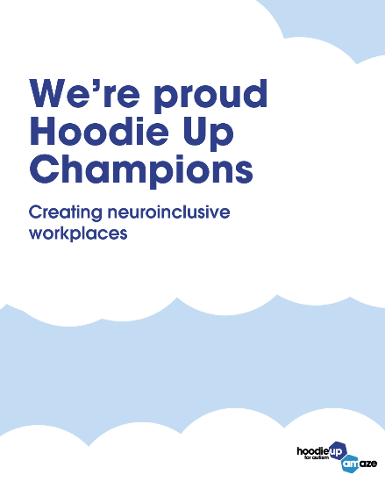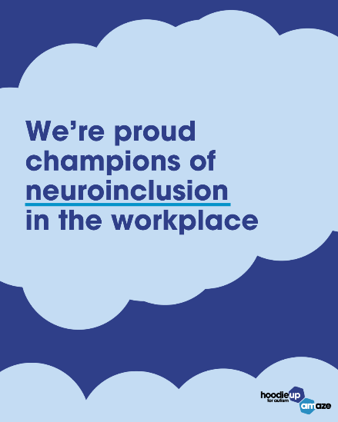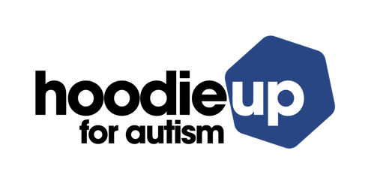

### Usage instructions

You can use these assets for external promotion of your organisation’s Hoodie Up day.

For internal assets and resources, please contact [**inclusion@amaze.org.au**](mailto:inclusion@amaze.org.au)

### Newsletter

We’re proud to be Hoodie Up Champions!

This year we’ve joined Amaze’s Hoodie Up campaign to show our support for Autistic people and their families.

Hoodie Up is a great complement to our organisation’s existing neuroinclusion and diversity initiatives.

We are proud to support and create space for Autistic people to confidently be their true selves.

You can contact Amaze if you have any questions at **inclusion**[**@amaze.org.au**](mailto:community@amaze.org.au)or read more on Amaze’s website [**Hoodie Up for Autism - Amaze**](https://www.amaze.org.au/get-involved/hoodie-up/)

### Website

Champion inclusion and hoodie up to show your support for Autistic people and their families!

We’ve joined Amaze’s annual Hoodie Up campaign to celebrate and uplift the Autistic community, while promoting understanding, acceptance and inclusion in society.

The theme for 2025 is ‘My Positive Autistic Identity’

It’s all about celebrating the strength, uniqueness, and pride of being Autistic.

The 2025 campaign focuses on embracing and uplifting the positive aspects of Autistic identity, empowering individuals to fully appreciate and take pride in their experiences.

It challenges limiting stereotypes and highlights the incredible skills, perspectives, and joys that come with being Autistic.

The campaign encourages everyone to reflect on their own positive Autistic identity, while fostering a community that supports and creates space for Autistic people to confidently be their true selves.

Read tips on how to get involved on Amaze’s website [**Hoodie Up for Autism - Amaze**](https://www.amaze.org.au/get-involved/hoodie-up/)

### Socials

**Facebook, Instagram and LinkedIn**

We’re proud to be Hoodie Up Champions!

This year we’ve joined Amaze’s Hoodie Up campaign to show our support for Autistic people and their families.

Hoodie Up is a great complement to your organisation’s existing neuroinclusion and diversity initiatives.

We encourage other organisations to take part to foster a community that supports and creates space for Autistic people to confidently be their true selves.

Read tips on how to get involved on Amaze’s website [**Hoodie Up for Autism - Amaze**](https://www.amaze.org.au/get-involved/hoodie-up/)

## Copy and images to use for community

 

### Newsletter

We’re proud to be Hoodie Up Champions!

This year we’ve joined Amaze’s Hoodie Up campaign to show our support for Autistic people and their families.

We are proud to support and create space for Autistic people to confidently be their true selves.

You can contact Amaze if you have any questions at **info**[**@amaze.org.au**](mailto:community@amaze.org.au) or read more on Amaze’s website [**Hoodie Up for Autism - Amaze**](https://www.amaze.org.au/get-involved/hoodie-up/)

### Website

Champion inclusion and hoodie up to show your support for Autistic people and their families!

We’ve joined Amaze’s annual Hoodie Up campaign to celebrate and uplift the Autistic community, while promoting understanding, acceptance and inclusion in society.

The theme for 2025 is ‘My Positive Autistic Identity’

It’s all about celebrating the strength, uniqueness, and pride of being Autistic.

The 2025 campaign focuses on embracing and uplifting the positive aspects of Autistic identity, empowering individuals to fully appreciate and take pride in their experiences.

It challenges limiting stereotypes and highlights the incredible skills, perspectives, and joys that come with being Autistic.

The campaign encourages everyone to reflect on their own positive Autistic identity, while fostering a community that supports and creates space for Autistic people to confidently be their true selves.

Read tips on how to get involved on Amaze’s website [**Hoodie Up for Autism - Amaze**](https://www.amaze.org.au/get-involved/hoodie-up/)

### Social media

**Facebook, Instagram and LinkedIn**

We’re proud to be Hoodie Up Champions!

We’ve joined Amaze’s Hoodie Up campaign to celebrate the strengths, uniqueness and pride in being Autistic.

We encourage everyone to take part in fostering a community that supports and creates a space for Autistic people to confidently be their true selves.

Read tips on how to get involved on Amaze’s website [**Hoodie Up for Autism - Amaze**](https://www.amaze.org.au/get-involved/hoodie-up/)

**#HoodieUp2025 #MyPositiveAutisticIdentity**

|  |  |  |
| --- | --- | --- |
|  |  |  |

**Amaze**

678 Victoria Street

Richmond VIC 3121

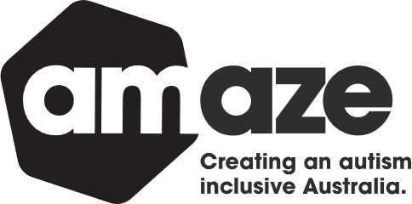

PO Box 374

Carlton South VIC 3053

Phone: 03 9657 1600

Email: info@amaze.org.au

[www.amaze.org.au](https://amazevic-my.sharepoint.com/personal/jenni_mazaraki_amaze_org_au/Documents/Desktop/Campaigns/Hoodie%20Up/www.amaze.org.au)

 [/AmazeAutismAU](https://www.facebook.com/AmazeAutismAU)

Twitter icon [@AmazeAutismAU](https://twitter.com/AmazeAutismAU)

Instagram Icon [@AmazeAutism](https://www.instagram.com/amazeautism/)

Linkedin Icon [/AmazeAutism](https://www.linkedin.com/company/amazeautism/)

You Tube Icon [@AmazeAutismAU](https://www.youtube.com/@AmazeAutismAU)