Disability Inclusion Transition Funding

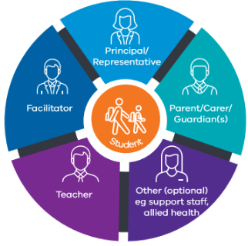
Disability Inclusion is the new strengths-based approach to supporting students with disability in Victorian government schools.

Disability Inclusion reforms
These reforms introduce a new three-tiered funding model and Disability Inclusion Profile for students with disability.
Under Disability Inclusion, schools have more funding and resourcing to support students with disability.
Disability Inclusion is being introduced in Victorian government schools over five years from 2021 to 2025. When schools begin Disability Inclusion depends on the Local Government Area (LGA) they are in.
To help give schools and families more certainty as they transition from the Program for Students with Disabilities (PSD) to the new approach, the Victorian Government is providing schools with Disability Inclusion Transition Funding.
Disability Inclusion Transition Funding makes sure that schools receive the same amount of funding or more to support students
transitioning from the PSD to Disability Inclusion.

Disability Inclusion Profile
The Disability Inclusion Profile is a strengths-based process to help schools and families identify:
• your child’s needs
• the educational adjustments schools can make to support your child.
The Disability Inclusion Profile is completed in a Student Support Group meeting with you and key people who understand your child’s education and support needs. A facilitator helps schools and families work through the profile together.
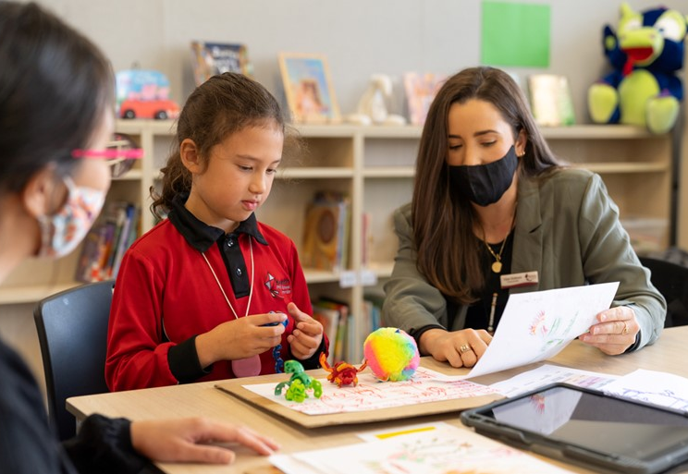
The Victorian Government will review Disability Inclusion Transition Funding for schools after 2024.
For more information about Disability Inclusion, its rollout and how Disability Inclusion Transition Funding may apply to your child, please visit: https://www.vic.gov.au/disability-inclusion-extra-support-children-disability or speak to your school’s principal.

