Amaze Position Statement
Autistic women and girls
Key points
- The current estimated ratio of autistic boys and men, to autistic girls and women, is 3:1. However girls and women continue to be underrepresented in autism prevalence data.
- The ongoing systemic failure to identify and diagnose autistic girls and women results from a lack of recognition and understanding across sectors of the differences in how autism presents in girls and women compared to boys and men, as well as historic gender biases in autism screening and diagnostic tools.
- Many autistic girls and women are not receiving the supports and services they need throughout their lifetime and are at increased risk of misdiagnosis, abuse, financial hardship and social isolation.
- Amaze recommends:
- The Victorian government adopt the recommendations in the Final Report to the Inquiry into services for people with autism spectrum disorder, to improve access to diagnoses, services and supports for autistic girls and women.
- The Commonwealth government endorse the national guideline for autism diagnosis and fund research into screening and diagnostic tools for recognising autism in girls and women.
- The NDIA take comprehensive steps to ensure that autistic girls and women are better supported throughout the NDIS planning process, and that autistic girls and women can access cost-effective supports and services.

- Background
The estimated ratio of autistic boys and men to autistic girls and women varies significantly between studies, with estimates ranging from 1.33:1 to 16:1. The average and most regularly reported estimate is a ratio of 4:1 autistic boys and men to autistic girls and women. However, a recent meta-analysis of prevalence studies conducted since 1994 found that the ratio is closer to 3:1. Variations in the boys and men to girls and women ratio are consistently reported according to cognitive ability, with a wider ratio estimated for autistic boys/men to autistic girls/women with an average or above average IQ (5.5:1), compared to boys/men and girls/women with a moderate to severe intellectual disability (2:1).
It is widely accepted that autistic girls and women (particularly without an intellectual disability) are likely to be underrepresented in the data, primarily due to the different ways in which their autistic characteristics can present, compared to autistic boys/men, and historical gender biases in autism screening and diagnostic tools.
There is emerging evidence that autistic people may be represented in greater numbers in asexual and transgender communities, compared with the general population. Any references to girls and women in this position statement include transsexual and transgender girls/women.

- Current experiences
Women, and the parents and carers of girls, face numerous barriers when seeking an autism assessment and diagnosis, supports and services across their lifetime. As a result, autistic girls and women can face discrimination in many aspects of life and may be at increased risk of violence and abuse. The social and economic impacts to autistic girls and women, their families and the community are significant.
- Failures to recognise the differences in presentation between autistic girls/women and boys/men
The failure to identify and diagnose autistic girls and women largely results from a lack of knowledge, particularly among health and education professionals, of how autism can present in autistic girls/women, compared to autistic boys/men. In particular, concerns raised with General Practitioners by parents of girls are often dismissed, leading to later referral, assessment and diagnosis.
Studies examining the presentation and true representation of autistic girls and women are limited. Within the available evidence, there is substantial variation in findings regarding differences in autism severity, and the differences in autistic characteristics, between autistic boys/men and girls/women. However, many studies have found that:
- Autistic girls and women (particularly without a co-occurring intellectual disability) are often are unable to obtain a diagnosis of autism, as they have better capabilities to cope in the short term, imitate social skills and adapt or suppress some of their autistic characteristics (including during assessment/diagnosis). Autistic women report that in the long term these techniques are exhausting and cannot be sustained for long periods of time.
- Autistic girls/women can appear to have stronger language and social communication skills than autistic boys/men (particularly in the early years due to echolalia), although girls/women often have greater difficulties forming and maintaining friendships than autistic boys/men.
- Special interests and atypical play in autistic girls can differ to autistic boys and be much more subtle. For example, girls are more likely to engage in imaginative play and their special interests are more likely to be similar to the interests of same age peers. However, the intensity, purpose and way they approach their imaginative play and special interests, such as through scripting play and imitating the play of others, may be very different from their peers.
- Autistic girls and women are often more likely to internalise their anxiety or be able to verbalise their emotions, resulting in them being less likely to externalise their emotions or resort to physically aggressive behaviours. In the absence of externalised emotions or physical aggression, girls and women may be less likely to be referred for diagnostic assessment. Consistent with gender stereotypes, girls are often simply labelled as shy or as having a passive personality.
The prevalence of mental health conditions, such as anxiety and depressive disorders, are higher among autistic girls/women that autistic boys/men.

- Gender biases in autism screening and assessment tools
There is evidence that girls and women with equivalently high levels of so called ‘autistic-like traits’ are less likely than boys and men to meet the diagnostic criteria for autism. Recent surveys suggest that girls are on average being diagnosed later than boys (often requiring numerous assessments) and are often not diagnosed until adolescence or adulthood.
As discussed above, this is largely due to a lack of recognition and understanding of the differences in how autistic boys/men and autistic girls/women present. However, historical gender bias in screening and assessment tools is also a key factor.
There is evidence that commonly used autism screening and diagnostic tools (such as the Autism Diagnostic Observation Schedule [ADOS] and the Autism Diagnostic Interview–Revised [ADI-R]), reflect a presentation more commonly found in boys/men than girls/women, and may lack the sensitivity and specificity required to identify autistic characteristics in girls/women. The latest revision of the criteria for diagnosing autism in the Diagnostic and Statistical Manual of Mental Disorders (DSM-5), is accompanied by a statement that girls with autism might not be diagnosed due to gender differences, and that “girls without accompanying intellectual impairments or language delays may go unrecognized, perhaps because of subtler manifestations of social and communication difficulties”. However, studies to date have failed to find and that the application of the DSM-5 criteria identifies autistic girls or women any more (or less) reliably than DSM-4.
As a result of not being diagnosed, or a late diagnosis, many autistic girls are missing out on funding and appropriately tailored early intervention services. It is well established that intensive early intervention support for autistic children is key to increasing their developmental trajectory over their lifetime, allowing them to be as independent as possible and participate to their full potential in education, employment and their community. Furthermore, autistic girls and women wrongly diagnosed with other conditions, such as learning disabilities, anxiety and/or eating disorders, may be undergoing unnecessary interventions and/or taking unnecessary medications.
Many school aged girls that have been diagnosed with autism often fail to meet the criteria for school based funding (for an aide and/or other supports) due to their language skills and/or lower levels of disruptive behaviour. Teachers are also failing to recognise and accommodate the potentially different learning needs and executive functioning challenges of girls, which can lead to frustration and anxiety, as well as suspension and exclusion.
Many intervention programs and approaches are designed with the stereotypically male characteristics of autism in mind. Social skills groups, community groups and other group based interventions will often be populated by significantly more boys/men than girls/women. However, the barriers to, and development of, communication and social skills in autistic girls/women can be very different to that of autistic boys/men, with significant implications for the design and implementation of intervention programs. While there are some emerging interventions and social groups for autistic girls and women, such as Yellow Ladybugs, they are not widely available or capable of supporting large numbers of girls or women. Little support is available for autistic women diagnosed later in life.
Furthermore, many autistic women are not diagnosed until their children are diagnosed with autism. Autistic mothers can face particular challenges and require specific supports, particularly in relation to executive functioning (i.e. in task planning and completion, impulse control and self-regulation). In the absence of support, autistic mothers can experience stigma, social isolation, anxiety and depression. A lack of understanding by health professionals and the broader community of the different ways autistic mothers may approach motherhood can lead to women feeling that their parenting approaches are less valid or inappropriate. Autistic mothers have also reported a range of difficulties, and lack of understanding and support from planners, when advocating for themselves or their children in relation to the National Disability Insurance Scheme.
Into adulthood, autistic women can experience challenges in workplaces that lack understanding and/or fail to make the adjustments necessary to enable full workplace participation (such as adjustments to support executive functioning or sensory needs). It has also been reported that Disability Employment Services can lack an understanding of autism in women and how this may impact the process of seeking employment, attending interviews and retaining employment. Disability Employment Services and employers also often fail to recognise the strengths and skills of autistic women, such as visual thinking and attention to detail, and the valuable contribution they can make in the workforce.
- Discrimination against autistic girls and women, and risk of abuse
Autistic girls and women can be extremely vulnerable if they have difficulty understanding social relationships and/or the real intent behind what people say or do, particularly in relationships and when engaging in social media. Autistic girls and women may also be at increased risk, compared to girls and women generally, of bullying, verbal abuse and violence across their lifetime (dependence on others to communicate also increases vulnerability and may reduce reporting). Women, particularly women that remain undiagnosed, are often unable to access adequate protection or appropriate supports. Indications of violence against autistic girls and women may also be difficult to identity and will often be misconstrued by health professionals, and professionals and staff across other sectors, as characteristics of their autism or co-occurring conditions.
- The impacts on individuals, families and the community
The failure to diagnose and support autistic girls and women is having a significant impact on these girls and women, their families and the community as a whole. Many autistic women report that due to a lack of support and compassion throughout their lives (from school, to employment and other areas of life) they have always felt different and been unable to understand why. As discussed above, women are more likely to have one or more co-occurring mental health condition. Autistic girls/women also appear to be more socially isolated and without peer support than autistic boys/men, struggling with friendships and social activities throughout their lifetime.
The costs to families paying for numerous assessments to inform diagnostic evaluations, funding early and ongoing intervention and seeking support for co-occurring mental health conditions can also be significant. Parents report difficulties accessing their local community and feeling socially isolated. The social costs to governments and the wider community of autistic girls and women being unable to access the support they need can be estimated to be in the billions. In 2011, the annual economic costs of autism in Australia was estimated between $8.1 billion and $11.2 billion, with the most significant costs arising from reduced employment and the cost of informal care for autistic adults.
Many women who have received an autism diagnosis in adulthood have expressed feelings of self-acceptance and relief on finally understanding why they always felt different and knowing that there are like people out there. Being able to connect with other autistic women through autistic women’s networks and being able to finally access appropriate services has been life changing for many autistic women (including by creating a sense of belonging in the autistic community and improving mental health).

- Next steps.
In June 2017, the Victorian parliament released its Final Report from its Inquiry into services for people with autism spectrum disorder. In its Final Report, the Victorian parliament recognised many of the current barriers to autistic girls and women accessing an autism diagnosis and appropriate services and support in Victoria. Among the Final Report’s 101 recommendations, it recommended that the Victorian government update its State Autism Plan and specifically provide for girls and women in that plan. It also recommended that the Victorian government ensure that:
- when developing policies, programs, services and supports for people with autism, or impacting on people with autism, the Victorian Government, local governments, all service providers and professionals consult and engage with people with autism, their families and advocates.
- training and professional development is provided to health professionals diagnosing autism in the recognition of how girls present with autism, including gender specific behaviours and symptoms;
- training and professional development in autism is provided to teachers to understand how girls with autism present, and the learning needs of girls with autism;
- it advocate to the National Disability Insurance Agency (NDIA) to provide grant funding opportunities to community groups that specifically offer support programs and activities to girls and women with autism (such as Yellow ladybugs and The Sisterhood Society Australia); and
- any employment strategy (recommended to be developed under the updated State Autism Plan) make specific provision for the needs of autistic women.
Amaze welcomed the Victorian government’s commitment in December 2017, in response to the Victorian Parliament’s recommendations above, to develop a State Autism Plan and work with the autism community “to develop mentoring, peer support, advocacy and social opportunities” for autistic girls and their families.
Amaze is strongly advocating to the Victorian government to adopt all of the recommendations in the Victorian Parliament’s report. However, as a first step, equal numbers of autistic women and men (including transgender) and families and carers of autistic girls/women and boys/men should be consulted about their experiences, needs and barriers to support and services.
In September 2017, Australia’s Cooperative Research Centre for Living with Autism (Autism CRC) released Australia’s first draft national guideline for autism diagnosis (developed by Autism CRC in collaboration with the NDIA). The Guideline aims to create greater consistency in diagnostic practices across Australia. The draft guideline highlights different presentations among autistic girls/women compared to autistic boys/men, the importance of diagnosis to autistic girls/women and their families and advises all professionals involved in autism assessments to consider the individual’s behavioural presentation and needs in comparison to other individuals of the same gender (rather than comparing girls/women to the stereotypical male presentation). It also highlights the evidence that trans or gender diversity is more common in autistic people, compared to the broader population, and recommends that professionals involved in autism assessments have a good understanding of gender diversity, and its potential impact on the individual’s behavioural presentation and needs.
Amaze would also welcome the ongoing review of screening and diagnostic criteria to ensure they are appropriately adapted to girls and women. Current steps to develop new screening and assessment tools should be encouraged. For example, Professor Tony Attwood and colleagues are continuing to build the validity and robustness of their Questionnaire for Autism Spectrum Conditions (Q-ASC), developed in 2011 as a screening tool with greater specificity to diagnose girls and women (without intellectual disabilities). There is also evidence that the Autism Spectrum Screening Questionnaire (ASSQ) – Revised Extended version (2011) may be more sensitive to autistic girls and women and better able to discriminate between autistic and non-autistic girls and women. Further research into these tools is encouraged, in coordination with studies evaluating the sensitivity of DSM-5 criteria to autistic girls and women. Health practitioners and professionals across other sectors that interact with autistic girls and women should be encouraged via the diagnostic guideline and other means to keep informed of emerging evidence and new assessment and diagnostic tools.
Amaze encourages the Victorian state government to adopt all of the recommendations from the recent Review of the Program for Students with Disabilities (PSD), including that it reform the PSD criteria for individual funding in schools, removing the language criteria and making the criteria equitable, targeted and based on strengths and functional need. This reform will be key to building the capacity of autistic girls to access much needed support in Victorian schools. As noted above, teacher training to recognise autism in girls and support autistic girls is urgently needed.
The NDIA is engaged in an ongoing review of its planning process and has recently implemented some changes to improve the process for participants. Amaze will continue to encourage the NDIA to improve its planning process and provide training for NDIA staff, Local Area Coordinators and Early Childhood Early Intervention Partners on autism in women, and how autistic mothers and autistic women may be better supported throughout the NDIS planning process. It will also urge the NDIA to evaluate the effectiveness of services and supports currently being provided to autistic women under the NDIS, partner with researchers to identify the most cost effective supports and interventions for autistic girls and women, provide guidance to service providers and take steps to ensure there are appropriate services accessible to autistic girls and women across Australia.

- Key recommendations

- The Victorian government adopt the recommendations in the Final Report to the Inquiry into services for people with autism spectrum disorder, to improve access to diagnoses, services and supports for autistic girls and women.
- The Commonwealth government endorse the national guideline for autism diagnosis developed by Autism CRC in collaboration with the National Disability Insurance Agency.
- Australian governments and/or the NDIA fund research into the specificity and reliability of screening and diagnostic tools for recognising autism in girls and women, including the development of new tools as appropriate.
- The NDIA take comprehensive steps to ensure that autistic women are better supported throughout the NDIS planning process, and that girls and women can access cost-effective supports and services.

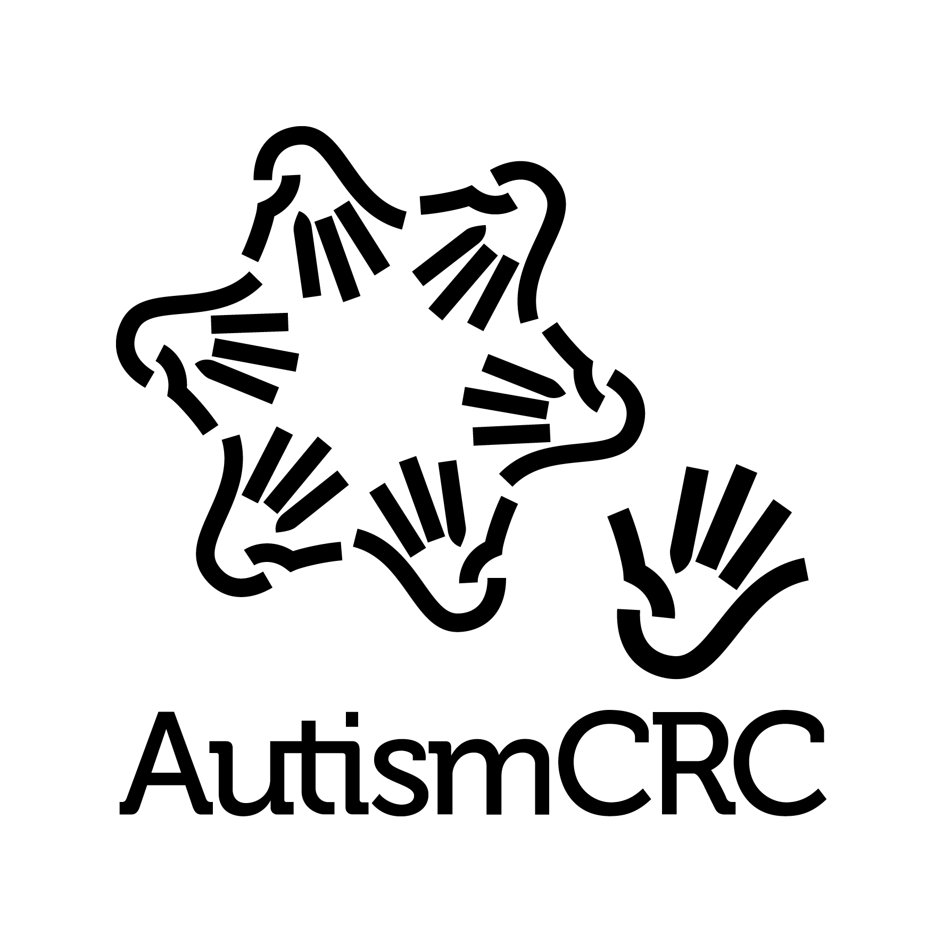
Endorsed by:
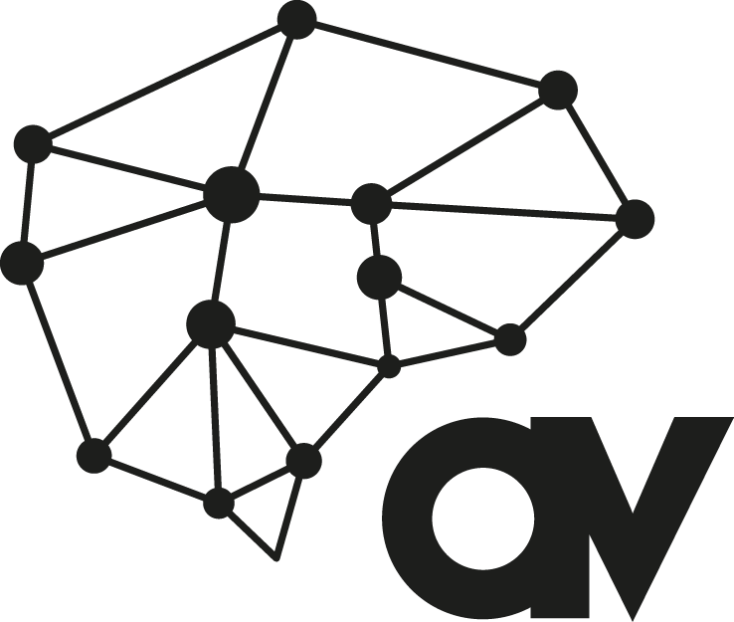

Attribution:
This work should be referenced as:
Amaze 2018, Position Statement – Autistic Women and Girls, available at
www.amaze.org.au

- References

Rivet T and Matson J 2011. Review of gender differences in core symptomatology in autism spectrum disorders, Research in Autism Spectrum Disorders, vol. 5, no. 3, pp. 957–976.
Ibid.
Loomes R et al 2017. What is the Male-to-Girls/women Ratio in Autism Spectrum Disorder? A Systematic Review and Meta-Analysis. J Am Acad Child Adolesc Psychiatry, vol 26, no, 6, pp. 466-474
Fombonne E 2005. The changing epidemiology of autism. Journal of Applied Research in Intellectual Disabilities, vol 18, no. 4, pp.281-294.
Loomes R et al 2017. What is the Male-to-Girls/women Ratio in Autism Spectrum Disorder? A Systematic Review and Meta-Analysis. J Am Acad Child Adolesc Psychiatry, vol 26, no, 6, pp. 466-474; Dworzynski K et al 2012. How different are girls and boys above and below the diagnostic threshold for autism spectrum disorders?, Journal of the American Academy of Child & Adolescent Psychiatry, vol. 51, no. 8, 2012, pp. 788-797; Rivet T and Matson J 2011. Review of gender differences in core symptomatology in autism spectrum disorders, Research in Autism Spectrum Disorders, vol. 5, no. 3, pp. 957–976; Lai, M., et al 2015. Sex/gender differences and autism: Setting the scene for future research. Journal of the American Academy of Child and Adolescent Psychiatry, vol. 54, no, 1, pp. 11-24, available at https://www.ncbi.nlm.nih.gov/pmc/articles/PMC4284309/
Glidden D et al. 2016. Gender Dysphoria and Autism Spectrum Disorder: A systematic review of the literature. Sexual Medicine Reviews, vol 4, pp. 3 – 14.
Victorian Parliament 2017. Inquiry into Services for People with Autism Spectrum Disorder - Final Report. Family and Community Development Committee. June 2017. Available at https://www.parliament.vic.gov.au/fcdc/article/2588.
Ibid.
Rutherford, M et al 2016. Gender ratio in a clinical population sample, age of diagnosis and duration of assessment in children and adults with autism spectrum disorder. Autism, vol. 20, no. 5, pp. 628 – 634; Novat N et al 2017.Maternal experience raising girls with autism spectrum disorder: A qualitative study. Child: Care, Health and Development, vol.43, no. 4, pp. 536-545.
Rivet T and Matson J 2011. Review of gender differences in core symptomatology in autism spectrum disorders, Research in Autism Spectrum Disorders, vol. 5, no. 3, pp. 957–976; Van Wijngaarden-Cremers PJ et al 2014. Gender and age differences in the core triad of impairments in autism spectrum disorders: a systematic review and meta-analysis. Journal of Autism and Developmental Disorders, vol. 44, no.3, pp.627-35
See for example, Kirkovski M et al 2013. A review of the role of girls/women gender in AUTISM. Journal of autism and developmental disorders, vol. 43, no. 11, pp.2584-603; Dworzynski K et al 2012. How different are girls and boys above and below the diagnostic threshold for autism spectrum disorders?, Journal of the American Academy of Child & Adolescent Psychiatry, vol. 51, no. 8, pp. 788-797; Rivet T and Matson J 2011, Review of gender differences in core symptomatology in autism spectrum disorders, Research in Autism Spectrum Disorders, vol. 5, no. 3, pp. 957–976; Van Wijngaarden-Cremers PJ et al 2014. Gender and age differences in the core triad of impariments in autism spectrum disorders: a systematic review and meta-analysis. Journal of Autism and Developmental Disorders, vol 44, no, 3, pp.627-35; Victorian Parliament 2017. Inquiry into Services for People with Autism Spectrum Disorder - Final Report. Family and Community Development Committee. June 2017. Available at https://www.parliament.vic.gov.au/fcdc/article/2588.
Blakemore M., Robertson G., et al. 2016. Multiple and intersecting forms of discrimination against autistic women – For the attention of the Special Rapporteur on Violence against Women. Contributing NGO’s – Autism Asperger Advocacy Australia (A4), Autistic Self Advocacy Network of Australia and New Zealand, Autistic Women’s Association, The Sisterhood Society Australia and Yellow Ladybugs. Available at http://www.australianautismalliance.org.au/wp-content/uploads/2017/03/Autistic-Women.pdf
Ibid.
Altman L, Turk J 2016. Comparison of autistic profiles in young girls/womens and males with AUTISM: A review of the literature. Journal of the American Academy of Child and Adolescent Psychiatry, vol. 55, no. 10, p.106; Attwood T and Grandin T (eds) 2006, Asperger’s and Girls, Future Horizons, Inc, Arlington Texas.
Altman L, Turk J 2016. Comparison of autistic profiles in young girls/womens and males with AUTISM: A review of the literature. Journal of the American Academy of Child and Adolescent Psychiatry, vol. 55, no. 10, p.106; Attwood T and Grandin T (eds) 2006, Asperger’s and Girls, Future Horizons, Inc, Arlington Texas.
Victorian Parliament 2017. Inquiry into Services for People with Autism Spectrum Disorder - Final Report. Family and Community Development Committee. June 2017. Available at https://www.parliament.vic.gov.au/fcdc/article/2588.
Autism Spectrum Australia (Aspect). We Belong: The experiences, aspirations and needs of adults with Asperger’s disorder and high functioning autism April 2013.
Dworzynski K et al 2012. How different are girls and boys above and below the diagnostic threshold for autism spectrum disorders?, Journal of the American Academy of Child & Adolescent Psychiatry, vol. 51, no. 8, 2012, pp. 788-797
Koulas K., Blakemore M., Yellow Ladybugs 2016. Submission to United Nations Office of the High Commissioner for Human Rights, November 2016. Available at https://www.ohchr.org/Documents/Issues/Children/2030/YellowLadybugs.pdf
Dworzynski K et al 2012. How different are girls and boys above and below the diagnostic threshold for autism spectrum disorders?, Journal of the American Academy of Child & Adolescent Psychiatry, vol. 51, no. 8, 2012, pp. 788-797.
Lai, M., et al 2015. Sex/gender differences and autism: Setting the scene for future research. Journal of the American Academy of Child and Adolescent Psychiatry, vol. 54, no. 1, pp. 11-24, available at https://www.ncbi.nlm.nih.gov/pmc/articles/PMC4284309/; Rynkiewicz, A., et al 2016. An investigation of the ‘girls/women camouflage effect’ in autism using a computerized ADOS-2 and a test of sex/gender differences. Molecular Autism, vol. 7, no. 1,pp. 1-8, available at https://molecularautism.biomedcentral.com/articles/10.1186/s13229-016-0073-0
Haney J 2015. Autism, Girls/womens, and the DSM-5: Gender Bias in Autism Diagnosis. October 2015. Social Work in Mental health. Available online via https://www.researchgate.net/publication/283467413_Autism_Girls/womens_and_the_DSM-5_Gender_Bias_in_Autism_Diagnosis
Koulas K., Blakemore M., Yellow Ladybugs 2016. Submission to United Nations Office of the High Commissioner for Human Rights, November 2016. Available at https://www.ohchr.org/Documents/Issues/Children/2030/YellowLadybugs.pdf
Prior M et al 2011. A review of the research to identify the most effective models of practice in early intervention of children with autism spectrum disorders. Australian Government Department of Families, Housing, Community Services and Indigenous Affairs, Australia.
Coombs E et al 2011, An investigation into the relationship between eating disorder psychopathology and autistic symptomatology in a non-clinical sample. British Journal of Clinical Psychology, 50(3), 326-338; Victorian Parliament 2017. Inquiry into Services for People with Autism Spectrum Disorder - Final Report. Family and Community Development Committee. June 2017. Available at https://www.parliament.vic.gov.au/fcdc/article/2588.
Victorian Parliament 2017. Inquiry into Services for People with Autism Spectrum Disorder - Final Report. Family and Community Development Committee. June 2017. Available at https://www.parliament.vic.gov.au/fcdc/article/2588; Altman L, Turk J 2016. Comparison of autistic profiles in young girls/womens and males with AUTISM: A review of the literature. Journal of the American Academy of Child and Adolescent Psychiatry, vol 5, no. 10, p.106; Koulas K., Blakemore M., Yellow Ladybugs 2016. Submission to United Nations Office of the High Commissioner for Human Rights, November 2016. Available at https://www.ohchr.org/Documents/Issues/Children/2030/YellowLadybugs.pdf
Moar T., Yellow Ladybugs 2016. Submission to Victorian Parliament’s inquiry into services for people with autism. Submission S117, available at https://www.parliament.vic.gov.au/images/stories/committees/fcdc/inquiries/58th/Autism/Submissions/S117_Yellow_Ladybugs.pdf
Autism Program at Yale, ‘Initiative for Girls and Women with Autism Spectrum Disorder. Yale School of Medicine. Available at https://medicine.yale.edu/childstudy/autism/clinical_services/initiative/
Yellow Ladybugs, see https://www.yellowladybugs.com.au/Event
Robertson G et al 2016. Multiple and intersecting forms of discrimination against autistic women – For the attention of the Special Rapporteur on Violence against Women. Contributing NGO’s – Autism Asperger Advocacy Australia (A4), Autistic Self Advocacy Network of Australia and New Zealand, Autistic Women’s Association, The Sisterhood Society Australia and Yellow Ladybugs. Available at http://www.australianautismalliance.org.au/wp-content/uploads/2017/03/Autistic-Women.pdf
Victorian Parliament 2017. Inquiry into Services for People with Autism Spectrum Disorder - Final Report. Family and Community Development Committee. June 2017. Available at https://www.parliament.vic.gov.au/fcdc/article/2588.
Blakemore M., Robertson G., et al. 2016. Multiple and intersecting forms of discrimination against autistic women – For the attention of the Special Rapporteur on Violence against Women. Contributing NGO’s – Autism Asperger Advocacy Australia (A4), Autistic Self Advocacy Network of Australia and New Zealand, Autistic Women’s Association, The Sisterhood Society Australia and Yellow Ladybugs. Available at http://www.australianautismalliance.org.au/wp-content/uploads/2017/03/Autistic-Women.pdf
Blakemore M., Robertson G., et al. 2016. Multiple and intersecting forms of discrimination against autistic women – For the attention of the Special Rapporteur on Violence against Women. Contributing NGO’s – Autism Asperger Advocacy Australia (A4), Autistic Self Advocacy Network of Australia and New Zealand, Autistic Women’s Association, The Sisterhood Society Australia and Yellow Ladybugs. Available at http://www.australianautismalliance.org.au/wp-content/uploads/2017/03/Autistic-Women.pdf
Blakemore M., Robertson G., et al. 2016. Multiple and intersecting forms of discrimination against autistic women – For the attention of the Special Rapporteur on Violence against Women. Contributing NGO’s – Autism Asperger Advocacy Australia (A4), Autistic Self Advocacy Network of Australia and New Zealand, Autistic Women’s Association, The Sisterhood Society Australia and Yellow Ladybugs. Available at http://www.australianautismalliance.org.au/wp-content/uploads/2017/03/Autistic-Women.pdf
Evidence from Ms Stacey Smith to Victoria’s Inquiry into services for people with autism – Public Hearing, Geelong, 19 September 2016, transcript of evidence, pp. 2 – 3.
Ibid.
Victorian Parliament 2017. Inquiry into Services for People with Autism Spectrum Disorder - Final Report. Family and Community Development Committee. June 2017. Available at https://www.parliament.vic.gov.au/fcdc/article/2588.
Koulas K., Blakemore M., Yellow Ladybugs 2016. Submission to United Nations Office of the High Commissioner for Human Rights, November 2016. Available at https://www.ohchr.org/Documents/Issues/Children/2030/YellowLadybugs.pdf; Blakemore M., Robertson G., et al. 2016. Multiple and intersecting forms of discrimination against autistic women – For the attention of the Special Rapporteur on Violence against Women. Contributing NGO’s – Autism Asperger Advocacy Australia (A4), Autistic Self Advocacy Network of Australia and New Zealand, Autistic Women’s Association, The Sisterhood Society Australia and Yellow Ladybugs. Available at http://www.australianautismalliance.org.au/wp-content/uploads/2017/03/Autistic-Women.pdf
Blakemore M., Robertson G., et al. 2016. Multiple and intersecting forms of discrimination against autistic women – For the attention of the Special Rapporteur on Violence against Women. Contributing NGO’s – Autism Asperger Advocacy Australia (A4), Autistic Self Advocacy Network of Australia and New Zealand, Autistic Women’s Association, The Sisterhood Society Australia and Yellow Ladybugs. Available at http://www.australianautismalliance.org.au/wp-content/uploads/2017/03/Autistic-Women.pdf
Blakemore M., Robertson G., et al. 2016. Multiple and intersecting forms of discrimination against autistic women – For the attention of the Special Rapporteur on Violence against Women. Contributing NGO’s – Autism Asperger Advocacy Australia (A4), Autistic Self Advocacy Network of Australia and New Zealand, Autistic Women’s Association, The Sisterhood Society Australia and Yellow Ladybugs. Available at http://www.australianautismalliance.org.au/wp-content/uploads/2017/03/Autistic-Women.pdf
Moar T., Yellow Ladybugs 2016. Submission to Victorian Parliament’s inquiry into services for people with autism. Submission S117, available at https://www.parliament.vic.gov.au/images/stories/committees/fcdc/inquiries/58th/Autism/Submissions/S117_Yellow_Ladybugs.pdf
Autism Spectrum Australia (Aspect). We Belong: The experiences, aspirations and needs of adults with Asperger’s disorder and high functioning autism April 2013; Koulas K., Blakemore M., Yellow Ladybugs 2016. Submission to United Nations Office of the High Commissioner for Human Rights, November 2016. Available at https://www.ohchr.org/Documents/Issues/Children/2030/YellowLadybugs.pdf
Ibid.
Koulas K., Blakemore M., Yellow Ladybugs 2016. Submission to United Nations Office of the High Commissioner for Human Rights, November 2016. Available at https://www.ohchr.org/Documents/Issues/Children/2030/YellowLadybugs.pdf
Ibid.
Synergies Economic Consulting 2011. Economic Costs of Autism Spectrum Disorder in Australia, Updated Study, April 2011, Synergies Economic Consulting Pty Ltd.
Victorian Parliament 2017. Inquiry into Services for People with Autism Spectrum Disorder - Final Report. Family and Community Development Committee. June 2017. Available at https://www.parliament.vic.gov.au/fcdc/article/2588
Victoria State Government 2017. Response to the Parliamentary Inquiry into Services for People with Autism Spectrum Disorder. Department of Health and Human Services, December 2017, available at https://www.parliament.vic.gov.au/file_uploads/Response_to_the_Parliamentary_Inquiry_into_Services_for_People_with_Autism_Spectrum_Disorder_59nNyXPV.pdf
Autism CRC 2017. The diagnostic process for children, adolescents and adults referred for assessment of autism spectrum disorder in Australia: A national guideline. Draft version for community consultation. September 2017. Available at https://www.autismcrc.com.au/get-involved/participate-study/national-guideline-now-open-community-consultation
Attwood T et al 2017. Profiling autism symptomatology in girls/womens: An exploration of the Q-ASC in a clinical setting. Available at https://www.researchgate.net/publication/313743248_PROFILING_AUTISM_SYMPTOMATOLOGY_IN_GIRLS/WOMENS_AN_EXPLORATION_OF_THE_Q-ASC_IN_A_CLINICAL_SETTING
Haney J 2015. Autism, Girls/womens, and the DSM-5: Gender Bias in Autism Diagnosis. October 2015. Social Work in Mental health. Available online via https://www.researchgate.net/publication/283467413_Autism_Girls/womens_and_the_DSM-5_Gender_Bias_in_Autism_Diagnosis
Haney J 2015. Autism, Girls/womens, and the DSM-5: Gender Bias in Autism Diagnosis. October 2015. Social Work in Mental health. Available online via https://www.researchgate.net/publication/283467413_Autism_Girls/womens_and_the_DSM-5_Gender_Bias_in_Autism_Diagnosis
Victorian state government 2016, Inclusive education for all students with disabilities and additional needs: The government’s response to the review of the Program for Students with disabilities. Department of Education and Training.
For more information see Amaze 2017, Position Statement: Education. Available at www.amaze.org.au

