Amaze Position Statement
National Disability Insurance Scheme
Key points
- The National Disability Insurance Scheme (NDIS) has the potential to be life changing for people with disability in Australia.
- With autistic people constituting almost one third of all NDIS participants, a high-level understanding of autism is required across the National Disability Insurance Agency (NDIA) and its partner agencies.
- Cost minimisation and efficiencies must not undermine the core values of the NDIS: that it be participant led and that participants be supported to exercise choice and control over the supports they receive.
- Amaze recommends that Australian governments fully fund the NDIS and work in partnership with autistic people and the autism community to ensure that:
- All autistic people (and children under 7 years showing precursory autism-like or autism-like traits) are receiving the supports they require under the NDIS as Participants and/or via NDIS Information, Linkages and Capacity Building activities.
- The NDIA invests in pre-planning support and peer networks, as well as NDIS resources that are tailored to the needs of autistic people.
- Autistic people are given an informed choice about how they engage in the planning process and given adequate opportunities to provide information to planners.
- Autism specific training is prioritised for all individuals and services that interface with the NDIS.
- Alternate funding methods are investigated to stimulate growth in the disability services sector.

- Background.
The National Disability Insurance Scheme (NDIS) is the largest social reform in Australia since Medicare. It represents an outstanding opportunity to address failures in current disability care and support systems, with a fundamental paradigm shift from a ration based system to a rights based framework.
The NDIS will provide all eligible Australians under the age of 65, who have a permanent and significant disability, with the reasonable and necessary supports they need to enjoy an ordinary life. It aims to provide individualised packages of support to people with disability, and enable choice and control over the design and delivery of those supports. It also aims to ensure that all people with disability are connected into more accessible and inclusive communities, and maximise mainstream services through NDIS Information, Linkages and Capacity Building activities.
To most effectively and efficiently meet the needs of autistic people, the NDIS must be:
- People centred – informed by autistic people and their families/carers;
- For ALL autistic people;
- Maximise choice and control; and
- Delivered in adherence to insurance principles.

- The NDIS must be people centred – informed by autistic people and their families/carers.
The NDIS is person centred, with a general principle that people with disability should be involved in all decision-making processes that affect them (involving their families, carers, supporters or nominees if suitable) and where possible, make decisions for themselves.
Currently, 27% of all NDIS participants, and 47% of participants aged 0 – 14identify autism as their primary diagnosis. Accordingly, the NDIS must have an ‘autism specific’ approach to provide efficiencies in how the scheme works for autistic individuals and provide for their specific needs. It is essential that autistic people are empowered to set their own goals, be involved in every step of the NDIS planning process, and exercise self-determination through choice and control over their support services.
The large numbers of autistic people accessing the scheme, their families/carers and the autism sector must also be engaged by the Commonwealth Government and National Disability Insurance Agency (NDIA) on all aspects of the NDIS’s ongoing development and implementation. The lived experience of autism and the experiences of autistic people accessing the NDIS must help shape the scheme into the future.

- The NDIS must be for ALL autistic people
The NDIS must meet the diverse disability support needs of ALL autistic people; of all ages, all types/levels of support need and wherever they live across Australia.
Many autistic people will be eligible to access the scheme as an NDIS participant and access an individual package of funded supports. To become an NDIS participant, an eligible person must be under 65 years of age and have substantially reduced functional capacity. Eligible children under 7 years of age with an early diagnosis of autism or showing early signs of autism should always meet the eligibility requirements to enter the Early Childhood Early Intervention NDIS gateway and facilitated to access appropriate autism specific and evidence based supports after diagnosis.
An autistic person that does not meet the eligibility requirements, i.e. if their autistic characteristics are assessed by the NDIA as not substantially reducing their functional capacity, will not receive an individualised NDIS support package. However, the NDIS must support that person by providing access to information and resources, and building the capacity of mainstream services and the broader community to meet their needs, through NDIS Information, Linkages and Capacity Building funded activities. If that person experiences episodic reductions in their functional capacity as a result of their disability at certain times in their life, i.e. during transitions from primary school to secondary school and/or from secondary school to adult life, there should be options for that person to enter, exit and re-enter the scheme quickly, seamlessly and as required.
Given the large numbers of autistic people accessing the scheme, all individuals and organisations that interface with NDIS participants should be required to demonstrate or build a sound level of autism related knowledge and skill. In particular, Local Area Co-ordinators, Early Childhood Early Intervention Access Partners, NDIA planners and NDIA staff should understand the vast range of support needs autistic people may have and be able to access higher level/specialist autism expertise when required. The NDIA should be informed by autistic people and utilise expertise from within autism specialist organisations, including by ensuring their involvement in the planning process.
A skilled general workforce that understands the wide range of supports autistic people may need, and how to provide that support, is also crucial. This extends beyond those providing higher skilled roles such as allied health professionals, through to all staff working with autistic people in residential housing, day centres and staff providing other personal care and support.

- The NDIS must maximise choice and control
A core object of the NDIS is that it should enable people with disability to exercise choice and control in the pursuit of their goals and the planning and delivery of their supports. Choice and control, and indeed the sustainability of the NDIS, requires concerted development in both the supply and demand sides of the NDIS market.
On the demand side, NDIS participants and their families must be empowered to be strong self-advocates. They must demand quality and innovation in NDIS planning and administration, as well as quality support service provision. In particular, participants and/or their families/carers must have access to transparent, clear, comprehensive and up-to-date information about the planning process and reasonable and necessary supports. This information should be tailored to the needs of different audiences, including autistic people, and disaggregated by gender and life stages. Participants and their families/carers must be permitted to choose how they engage in the planning process, i.e. whether in person, by phone, by email or a combination of these methods. Adequate time must be provided during planning meetings or discussions to enable autistic participants to process questions and provide information. Participants should be permitted to provide any subsequent information via a further planning meeting, phone discussion or email (or combination of these methods) if required. Consistency across planners and how plans are developed and reviewed is also urgently needed.
Ongoing funding for Disability Support Organisations (DSO) is also essential to continue providing pre-planning workshops and peer support, including specialised support for autistic people. Amaze has been working as a DSO for the last 24 months and has observed the significant benefits of facilitated pre-planning and peer supported workshops. An early evaluation of DSO workshops has found that they are having a positive impact, specifically around the areas of disseminating NDIS information and building NDIS readiness, creating positive social and community inclusion and cohesion, and improving senses of self-determination.
On the supply side, a significant increase in the quantity, quality, range and responsiveness of disability supports is required to meet rising demands. In particular, accessing services in regional and remote locations for autistic people is currently very difficult, with people often reporting to Amaze having to travel many hours to access specialist services. In the short term, Australian governments and the NDIA must take a coordinated approach to stimulating growth in this sector. For example, by supporting workforce development and investigating alternative methods, such as an element of block funding for services in regional areas. Emerging research also supports the efficacy of delivering therapeutic services to remote locations via videoconferencing facilities. Ongoing price regulation of disability supports is necessary to ensure the continued market supply of disability supports, and that participants receive value for money.
Choice and control for autistic people can only exist if they have access to a range of service providers with sound knowledge and skills in autism.

- The NDIS must be delivered in adherence to insurance principles.
The NDIS is underpinned by insurance principles of investing early to increase a participant’s economic, social and community participation. It aims to improve long term outcomes while reducing long term costs to the scheme, governments and the broader community.
The NDIA is currently facing significant cost pressures, with a projection that by 2019-20 the NDIS will cost about $22 billion each year. In 2011, the annual social and economic costs of autism in Australia was estimated between $8.1 billion and $11.2 billion, with the most significant costs arising from reduced employment and the cost of informal care for autistic adults.
However, there is strong evidence that the economic gains of a fully implemented NDIS will far exceed its costs. For example, in 2011 the Productivity Commission estimated that a reasonable increase in employment for people with disabilities to 220,000 by 2050 would yield an economic benefit of around $32 billion in that year alone.
If the NDIS is not fully funded to enable autistic people to receive the cost-effective evidence based supports they need now, their life outcomes will be severely impacted. The social and economic costs of autism, together with the costs of the NDIS, will also continue to rise.
Systematic reviews of the evidence clearly demonstrate that intensive early intervention support for autistic children is key to increasing their developmental trajectory over their lifetime, allowing them to be as independent as possible and participate to their full potential in education, employment and their community. Current evidence shows that children must be supported to access high quality, multidisciplinary, family centred therapies, individually tailored to each child’s (and family’s) unique needs in line with evidence based best practice for guidelines for autistic children. Further research, including by and with autistic people, is encouraged to further develop existing guidelines and recommendations.
In the case of children showing precursory autism-like traits or autism-like traits, there should be no delay in a diagnosis of autism being facilitated with the assistance of an Early Childhood Early Intervention partner to ensure that autism specific evidence based interventions and supports can be accessed as soon as possible.

- Key Recommendations
- Australian governments and the NDIA consult and work in partnership with autistic people, their families/carers and the autism sector in their ongoing development and implementation of the NDIS.
- Australian governments fully fund the NDIS and ensure:
  - Ongoing investment, capacity building, monitoring and reporting by the NDIA to ensure ALL autistic people (and children under 7 years showing precursory autism-like or autism-like traits) are receiving the supports they require under the NDIS (as Participants and/or via ILC activities as appropriate).
  - Participants are given an informed choice about how they engage in the planning process (whether by phone, in person, via email or a combination of these methods), with adequate opportunities to provide information and control their plan development.
  - The NDIA develop and distribute clear and accessible information on the NDIS, tailored to the needs of different audiences, including autistic people. It must also ensure further investment in peer networks and pre-planning support, drawing on successful experiences funded through the DSO program.
  - Autism specific training (informed by autistic people and autism specialist organisations) is prioritised for all individuals and services that interface with the NDIS, including the NDIA, its partner agencies and registered service providers.
  - Significant increase in the quantity, quality, range and responsiveness of disability supports available to NDIS participants, particularly in remote and rural areas.

Endorsed by:
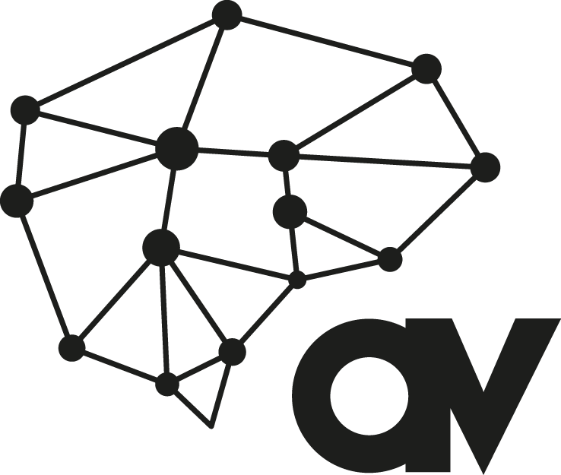

Attribution:
This work should be referenced as:
Amaze 2018, Position Statement – National Disability Insurance Scheme, available at
www.amaze.org.au

- References

National Disability Insurance Scheme (NDIS) Act 2013. For more information, see www.ndis.gov.au .
NDIS Act 2013, s.3.
For more information, see NDIS Information, Linkages and Capacity Building, at https://www.ndis.gov.au/communities/ilc-home
NDIS Act 2013, s.5.
Productivity Commission 2017. NDIS Costs – Productivity Commission Study Report. Australian Government. October 2017
NDIA 2nd Quarterly Report to COAG 2016-17 Q2, at https://www.ndis.gov.au/about-us/information-publications-and-reports/quarterly-reports
NDIS Act 2013, s. 24.
NDIS Act 2013, s. 25.
For more information, see NDIS Information, Linkages and Capacity Building at https://www.ndis.gov.au/communities/ilc-home
Productivity Commission 2017. NDIS Costs – Productivity Commission Study Report. Australian Government. October 2017
Ibid
NDIS Act 2013, s. 3(e).
Productivity Commission 2017. NDIS Costs – Productivity Commission Study Report. Australian Government. October 2017
Social Ventures Australia 2017, DSO evaluation (confidential).
Productivity Commission 2017. NDIS Costs – Productivity Commission Study Report. Australian Government. October 2017.
Ibid
Ibid
NDIA 2016, NDIA Annual Report 2015-16. file:///C:/Users/zjxa10/AppData/Local/Microsoft/Windows/INetCache/IE/DV058DMP/NDI7040-AnnualReport2016-vFaccessible.pdf
Synergies Economic Consulting 2011. Economic Costs of Autism Spectrum Disorder in Australia, Updated Study, April 2011, Synergies Economic Consulting Pty Ltd.
Productivity Commission 2011. Disability Care and Support, Report no. 54, Canberra
Synergies Economic Consulting, Economic Costs of Autism Spectrum Disorder in Australia, Updated Study, April 2011, Synergies Economic Consulting Pty Ltd.
Prior M, Roberts J, Roger S, Williams, K & Sutherland R 2011. A review of the research to identify the most effective models of practice in early intervention of children with autism spectrum disorders. Australian Government Department of Families, Housing, Community Services and Indigenous Affairs, Australia; Roberts J, Williams K 2016. Autism Spectrum Disorder: Evidence-based/evidence-informed good practice for supports provided to preschool children, their families and carers. Commissioned and funded by the NDIA. February 2016.

