Amaze Position Statement
Assessment and Diagnosis
Key points
- Autism assessment and diagnostic services should be available to all people who require them, irrespective of age, gender, locality, financial status, race or cultural identity.
- The earlier a diagnosis of autism can be made, the earlier evidence based autism-specific early intervention can commence, maximising outcomes for children, adolescents and adults, and increasing the developmental trajectory across their lifetime.
- Amaze supports the current development of a national diagnostic guideline for autism that promotes consistent and best practice autism diagnosis and ensures equal access to diagnosis.
- Amaze recommends that:
- The Commonwealth government adopt a national diagnostic guideline for autism.
- Australian governments fund research into the specificity and reliability of screening and diagnostic tools for recognising autism in females.
- The Victorian government agree to all evidence based recommendations arising out of the Victorian Parliament’s Inquiry into services for people with autism spectrum disorder, including by establishing a state-wide autism diagnostic service to co-ordinate screening, diagnosis, professional training and post diagnosis support.
- The Commonwealth and State/Territory governments commit to reducing the waiting time, from referral to autism diagnosis, to a maximum of three months.
- The National Disability Insurance Agency develop guidelines for National Disability Insurance Scheme (NDIS) Early Childhood Early Intervention (ECEI) staff regarding the timing and facilitation of a diagnosis (or encouraging diagnosis) when a child referred for developmental delay also, or later presents with the characteristics of autism.
- NDIS ECEI Access Partners be required to have a high level of autism specific expertise.

- Background
Across Australia, there is significant variability between states and territories in how Autism Spectrum Disorder (‘autism’) is assessed, particularly regarding the composition of the clinical diagnostic team. In some states, an autism diagnosis is made through consensus of an experienced multidisciplinary assessment team of a paediatrician / psychiatrist, psychologist and speech pathologist, while other states have less stringent criteria.
In Victoria, if a child is suspected of meeting the diagnostic criteria for autism, an assessment may be undertaken by a sole practitioner or a multi-disciplinary team of professionals experienced in autism.
A multi-disciplinary team will ordinarily be made up of a paediatrician (or child/ adolescent psychiatrist), a psychologist and a speech pathologist. Between them they will usually carry out a wide-ranging series of tests over several appointments. Once the assessment has been completed, the team will determine if the child meets the criteria for a diagnosis for autism and if appropriate, a diagnosis will be made. Alternatively, an assessment and diagnosis may be undertaken by a sole practitioner (such as a paediatrician) and that practitioner may or may not take into consideration evidence provided by a multi-disciplinary team.
International guidelines currently identify ‘Best practice’ assessments as including not only a medical and physical assessment, but a multidisciplinary team approach which provides appropriate cognitive testing, language assessment and information from more than one setting, ideally from a source other than the parent or carer (i.e. a school or kindergarten teacher) who has been interviewed.

- Current experiences
In the absence of a national autism diagnosis guideline and/or strategy in Australia, there remains considerable variability in autism screening and diagnostic practices. Assessments are not always reliable or consistent with international best practice guidelines. In addition, different diagnostic standards can apply between the health, education and disability public services, such that a diagnostic decision that is recognised by health or disability services early in life, may not be recognised by the education system when the child reaches school age.
The autistic community and their families/carers regularly share with Amaze their experiences in accessing an autism diagnosis. The barriers that are repeatedly shared and need to be addressed include:
- Lack of understanding of autism and its presentations by primary healthcare professionals such as local General Practitioners and Maternal and Child Health nurses;
- Lack of recognition and understanding of how autistic females present, and in turn a failure to refer or diagnose autistic females;
- A reluctance of paediatricians and paediatric psychiatrists to diagnosis autism under the age of three;
- Waiting lists for accessing diagnosis through the public health care systems;
- Limited access to diagnosticians in regional areas;
- Financial constraints for those seeking diagnosis through private diagnosticians, generally not wanting to wait for the public system;
- Lack of clear and concise information and support for families in navigating the diagnosis pathway.
These experiences are consistent with those highlighted in Australia’s Cooperative Research Centre for Living with Autism’s (Autism CRC) recently published report on autism diagnostic practices across Australia. This report also identified the following barriers:
- No current nationally consistent standard for diagnosis of autism;
- A higher frequency of diagnoses being provided by private sector relative to the public sector;
- Waiting times for diagnosis ranged from 1 week through to 2 years, with longer waits occurring in the public system and in regional, rural and remote Australia;
- Significant costs in accessing an assessment, ranging from $0 - $2,750, with median cost being $580; and
- Significant lack of clinicians providing diagnostic assessments in regional, rural and remote areas of Australia.
- Diagnosing autistic children and adolescents.
There is significant evidence that many autistic children can be reliably diagnosed by the age of 24 months and general agreement that children can demonstrate recognisable autism symptoms in their first 12 months of life. However, the average age of children (under 7 years of age and registered for the Australian Government’s Helping Children with Autism package) diagnosed with autism between 1 July 2010 and 30 June 2012 was 49 months - with the most frequently reported age being 71 months.
The earlier a diagnosis of autism can be made, the earlier autism-specific early interventions and supports can commence in line with evidence based best practice guidelines for autistic children - maximising outcomes/life experiences for children and increasing their developmental trajectory across their lifetime.
Prior to the introduction of the National Disability Insurance Scheme (NDIS), a diagnosis of autism was required to receive funding under the Helping Children with Autism scheme and many other State and Territory Government funded early intervention services. This encouraged the assessment and diagnosis of children presenting with characteristics of autism as early as possible.
However, under the NDIS Early Childhood Early Intervention (ECEI) pathway, a child under 6 years of age may enter the scheme on the basis of developmental delays, meaning he or she does not require a diagnosis. Currently, the steps being taken by the National Disability Insurance Agency (NDIA) and Early Childhood Partners towards diagnosis (or encouraging diagnosis,) when a child with developmental delay also or later presents with the characteristics of autism, remain unclear.
Amaze is concerned that the current approach under the NDIS ECEI may be delaying or dissuading families from exploring or accessing an autism diagnosis (and in turn, evidence based autism specific interventions and support) as early as possible.
- Diagnosing autistic adults
For many autistic people, their diagnosis of autism may not occur until adulthood, following many years of anxiety, social difficulties and challenges entering and maintaining employment. This is largely due to an ongoing lack of knowledge among health professionals of how autism presents in adulthood and their failures to delineate between autism and mental health conditions (such as anxiety or depression) or recognize the co-occurrence of autism with a mental health condition.
While some adults choose to see a professional for a diagnosis, others prefer not to: this is up the individual.
There are currently no publicly funded adult assessment clinics in Victoria. An adult seeking an assessment in Victoria would most commonly need to consult a psychologist and/or psychiatrist, ideally with experience in the assessment and diagnosis of autism in adults. However, for adults, accessing an autism assessment and diagnosis can be a very expensive process and it can be difficult to find a psychiatrist that specializes in autism assessment and diagnosis, particularly in rural areas.
Autistic adults commonly report that diagnosis in adulthood has been incredibly beneficial, including by: improving their understanding of past experiences, feelings and emotions; enhancing acceptance of self and/or by others; being empowered to better participate in all aspects of life and seek support where required; being introduced to concepts of accessibility and advocacy, as it applies to their new knowledge about themselves; and connecting with other members of the autistic community, online or in-person, allowing the sharing of experiences and feeling of belonging, within a community.
- Diagnosing autistic women and girls
There is significant evidence of a systemic failure to identify and diagnose autistic women and girls. This is predominantly due to a prevailing lack of recognition and understanding of the differences in how autism presents in women and girls compared to men and boys, as well as historic gender biases in autism screening and diagnostic tools.
Due to these failures, many autistic women and girls are not receiving the supports and services they need throughout their lifetime and are at increased risk of misdiagnosis, abuse, financial hardship and social isolation.

- What needs to be done?
Amaze welcomes Autism CRC’s development of a national diagnostic guideline for autism, commissioned under a collaboration between Autism CRC and the NDIA. As outlined in the draft guideline, released for consultation in September 2017, autism assessments must be guided by the principles of an individual and family centred, holistic, strengths focused and evidence based approach.
- National Guideline for autism diagnosis
The guideline must aim to achieve equal access to autism assessment and diagnosis. It must ensure that all Australians, regardless of age, gender, race, cultural identify, geographical location or financial status can access timely, consistent, rigorous and reliable diagnostic assessments that are feasible to deliver and acceptable to autistic people. The guideline should guide a consistent approach to assessment and diagnosis across all sectors, including health, education and disability public services. It should highlight the potential differences in how autism presents in autistic women and girls, compared to autistic men and boys, and improve access to rigorous and timely autism diagnosis in women/girls.
Professionals undertaking autism assessment and diagnosis must have the skills and experience to undertake a holistic assessment of a person’s presentation, with the capacity to appraise the full range of clinician symptoms, consider the environmental context and have strong regard to the person’s unique challenges and strengths (rather than simply matching an individual to a diagnostic criteria). They must also have a strong understanding of the many considerations that may impact a person’s presentation and experiences of autism, and the autism assessment process. These considerations include age, gender, culture, language, intellectual capacity and co-occurring conditions, such as genetic and co-occurring mental health conditions.
Finally, the guideline should highlight the limitations of current screening tools and diagnostic criteria, including their limitations in identifying autistic adults, and autistic women and girls. Government funding is needed for an organisation such as Autism CRC to review and if necessary, develop new tools and criteria, to ensure they are appropriately adapted to identifying autism in ALL people.
- Victorian Government strategy
The national diagnostic guideline for autism cannot exist in isolation. It must be accompanied by a broader government strategy to improve access to diagnosis. As recommended by the Victorian Parliament’s Family and Community Development Committee, in Inquiry into service for people with autism spectrum disorder – Final Report (Victorian Parliament’s report, 2017), a state-wide autism diagnostic service (established as a key element of the Victorian Government’s updated State Autism Plan) could efficiently co-ordinate screening, diagnosis, professional training and post diagnosis support for people of all ages.
There is also an urgent need for structured training and information resources to develop the autism knowledge of professionals involved in initiating an autism assessment (such as General Practitioners and Maternal and Child Health Nurses) and all clinicians involved in autism assessments and diagnosis (such as paediatricians, allied health providers and educators). Amaze therefore welcomes the Victorian State Government’s commitment, in response to the Victorian Parliament’s report, 2017, to ensure that all Maternal and Child Health nurses are better equipped to identify early signs of autism and refer children for diagnosis earlier. Greater co-ordination of early intervention pathways and services will also be essential to improved quality and efficiency. The waiting period to access public diagnostic services should be no longer than three months.
- The NDIS early intervention pathway
If a child without a diagnosis is referred to the NDIS but is presenting with obvious precursory autism -like traits or autism -like traits, either prior to, or after entry into the Scheme, a pathway to access an autism diagnosis as soon as possible should be available.
Accordingly, NDIS ECEI Access Partners should have a significant level of autism specific experience relating to the identification of early autism signs, diagnosis of autism, all evidence based clinical and therapeutic autism specific interventions and have the capacity to support families before and after diagnosis. Once the signs of autism are apparent to skilled and trained ECEI staff, there should be no delay in a diagnosis being facilitated with assistance from their ECEI partner and autism specific interventions and supports being included in the child’s NDIS plan.

- Key recommendations

- The Commonwealth government adopt a nationally consistent guideline for autism diagnosis to ensure equal access to diagnosis for all Australians, irrespective of age, gender, locality, financial status, race or cultural identity.
- The Victorian government establish a state-wide autism diagnostic service to co-ordinate screening, diagnosis, training and post diagnosis support.
- Centrally co-ordinated training for professionals involved in screening, initiating and undertaking autism related assessments to improve their understanding of autism, the early signs of autism and the experiences of autistic people.
- Australian governments fund research into the specificity and reliability of screening and diagnostic tools for recognising autism in ALL people (most notably, adults and women and girls), including the development of new tools as appropriate.
- The Commonwealth and State/Territory governments commit to reducing the waiting time, from referral to autism diagnosis, to a maximum of three months.
- NDIA develop guidelines for NDIA, LAC and ECEI staff regarding the appropriate timing and facilitation of accessing an autism diagnosis for participants or ECEI participants presenting with precursory autism -like traits or autism -like traits.
- NDIS ECEI Access Partners be required to have a high level of autism specific expertise.

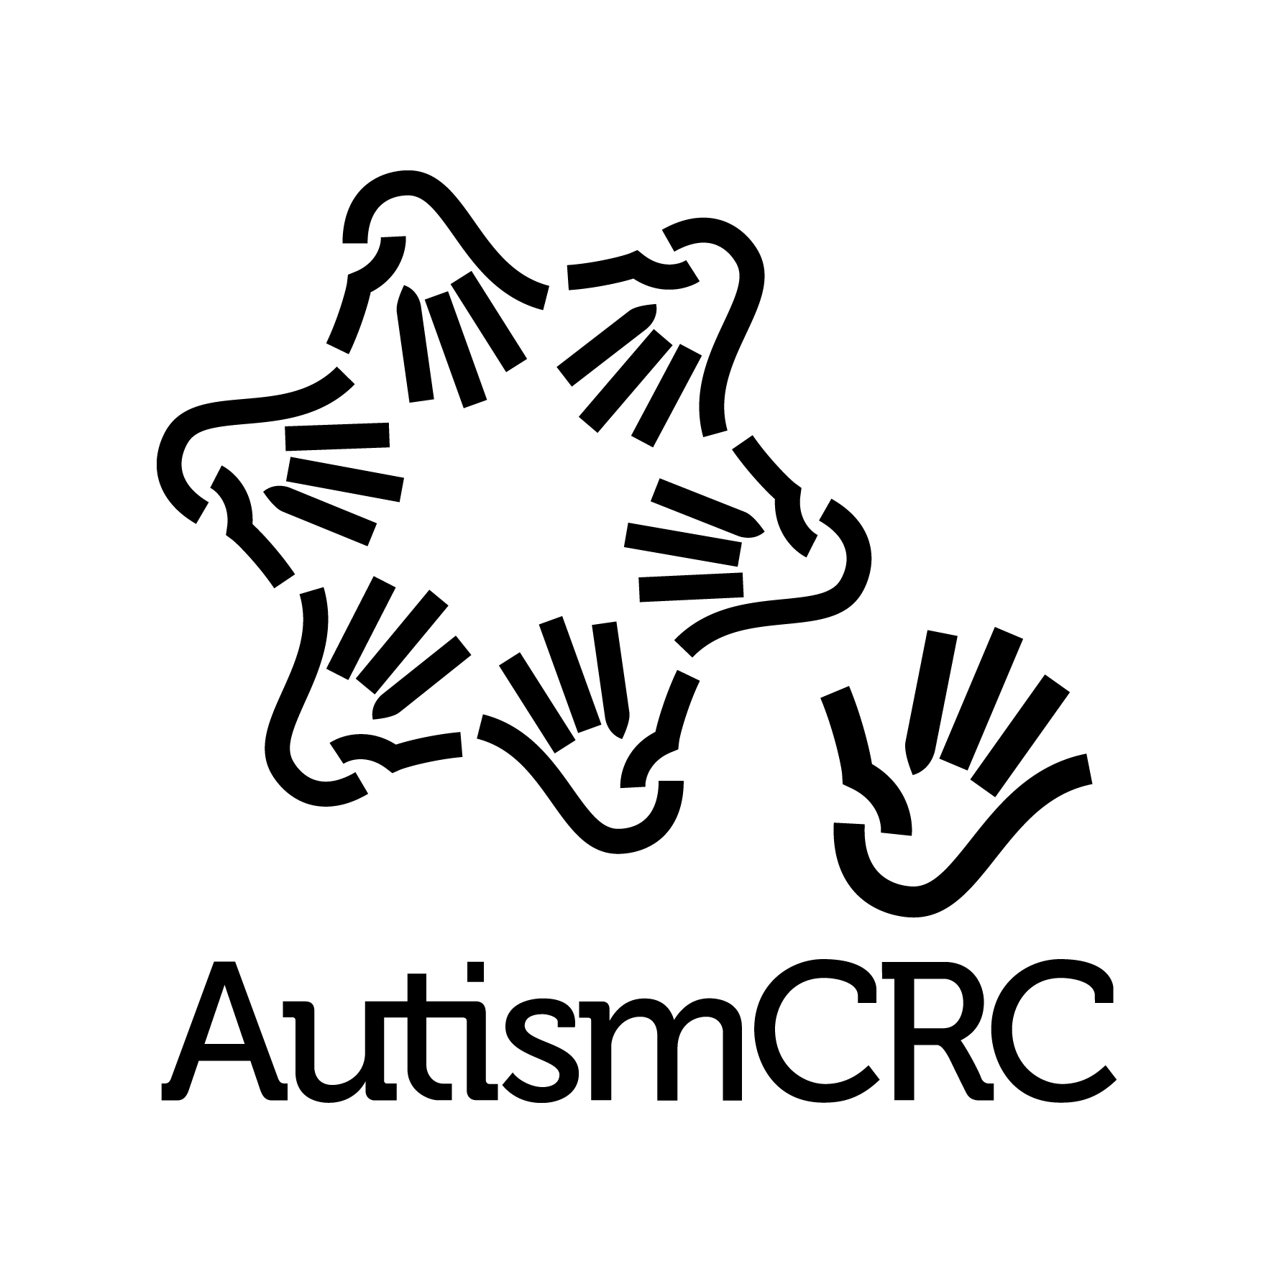
Endorsed by:

Attribution:
This work should be referenced as:
Amaze 2018, Position Statement – Assessment and Diagnosis, available at
www.amaze.org.au

- References

Autism CRC 2017. The diagnostic process for children, adolescents and adults referred for assessment of autism spectrum disorder in Australia’ -Draft version for community consultation. Available at https://www.autismcrc.com.au/get-involved/participate-study/national-guideline-now-open-community-consultation
American Psychiatric Association (2013) Diagnostic and statistical manual of mental disorders (5th ed.). US
Taylor, L., Brown, P., Eapen V et al (2016). Autism Spectrum Disorder Diagnosis in Australia: Are we meeting Best Practice Standards? Autism Co-operative Research Centre, Brisbane.
NICE. (2011). Autism in under 19s: recognition, referral and diagnosis. Available at https://www.nice.org.uk/guidance/cg128
Taylor, L., Brown, P., Eapen V et al (2016). Autism Spectrum Disorder Diagnosis in Australia: Are we meeting Best Practice Standards? Autism Co-operative Research Centre, Brisbane.
Autism CRC 2017, The diagnostic process for children, adolescents and adults referred for assessment of autism spectrum disorder in Australia’ -Draft version for community consultation. Available at https://www.autismcrc.com.au/get-involved/participate-study/national-guideline-now-open-community-consultation
Amaze (2016). Driving Change: Submission to the parliamentary inquiry into services for people with autism spectrum disorder. April 2016. Available at http://www.amaze.org.au/uploads/2016/06/Driving-Change-Amaze-Submission-Inquiry-into-service%E2%80%99s-for-people-with-autism-spectrum-disorder.pdf
Taylor, L., Brown, P., Eapen V et al (2016). Autism Spectrum Disorder Diagnosis in Australia: Are we meeting Best Practice Standards? Autism Co-operative Research Centre, Brisbane.
Guthrie, W., et al (2013). Early diagnosis of autism spectrum disorder: stability and change in clinical diagnosis. Journal of Child Psychology and Psychiatry, 54(5), 582–590. Available at http://www.researchgate.net/publication/232318674_Early_diagnosis_of_autism_spectrum_disorder_stability_and_change_in_clinical_diagnosis_and_symptom_presentation; Zwaigenbaum L et al (2015) Early Identification of Autism Spectrum Disorder: Recommendations for Practice and Research Pediatrics Oct 2015, 136 (Supplement 1) S10-S40; DOI: 10.1542/peds.2014-3667C
Bent C, Dissanayake C and Barbaro J (2015) Mapping the diagnosis of autism spectrum disorders in children aged under 7 years in Australia, 2010–2012. Med J Aust 2015; 202 (6): 317-320
Roberts J, Williams K (2016). Autism Spectrum Disorder: Evidence-based/evidence-informed good practice for supports provided to preschool children, their families and carers. Commissioned and funded by the NDIA. February 2016; National Guidelines, Best Practice in Early Childhood Intervention, Early Childhood Intervention Australia. April 2016.
A child under 6 years of age may access the NDIS, via the ECIA pathway, by demonstrating characteristics of developmental delay – Autism or other diagnosis is not required. National Disability Insurance Scheme Act 2013, s.25(1)(a)(iii)).
Victorian Parliament 2017. Inquiry into Services for People with Autism Spectrum Disorder - Final Report. Family and Community Development Committee. June 2017
Ibid.
Ibid.
See for example, Loomes R et al 2017. What is the Male-to-Female Ratio in Autism Spectrum Disorder? A Systematic Review and Meta-Analysis. J Am Acad Child Adolesc Psychiatry, vol 26, no, 6, pp. 466-474; Dworzynski K et al 2012. How different are girls and boys above and below the diagnostic threshold for autism spectrum disorders?, Journal of the American Academy of Child & Adolescent Psychiatry, 51(8), 788-797.
Autism CRC 2017, The diagnostic process for children, adolescents and adults referred for assessment of autism spectrum disorder in Australia’ -Draft version for community consultation. Available at https://www.autismcrc.com.au/get-involved/participate-study/national-guideline-now-open-community-consultation
Lai, M., et al 2015. Sex/gender differences and autism: Setting the scene for future research. Journal of the American Academy of Child and Adolescent Psychiatry, 54(1)11-24; Haney J 2015. Autism, Females, and the DSM-5: Gender Bias in Autism Diagnosis. October 2015. Social Work in Mental health. Available online via https://www.researchgate.net/publication/283467413_Autism_Females_and_the_DSM-5_Gender_Bias_in_Autism_Diagnosis
Victorian Parliament 2017. Inquiry into Services for People with Autism Spectrum Disorder - Final Report. Family and Community Development Committee. June 2017. Recommendation 3.1-3.8.
Victorian Parliament 2017. Inquiry into Services for People with Autism Spectrum Disorder - Final Report. Family and Community Development Committee. June 2017. Recommendation 3.1-3.5.
Victoria State Government 2017, Response to the Parliamentary Inquiry into Services for People with Autism Spectrum Disorder. Department of Health and Human Services, December 2017, available at https://www.parliament.vic.gov.au/file_uploads/Response_to_the_Parliamentary_Inquiry_into_Services_for_People_with_Autism_Spectrum_Disorder_59nNyXPV.pdf
Victorian Parliament 2017. Inquiry into Services for People with Autism Spectrum Disorder - Final Report. Family and Community Development Committee. June 2017. Recommendations 3.5-3.8.
Victorian Parliament 2017. Inquiry into Services for People with Autism Spectrum Disorder - Final Report. Family and Community Development Committee. June 2017. Recommendation 3.4.

